**LOAN MANAGEMENT SYSTEM DEMONSTRATION PROOFS**

**BACKEND VALIDATIONS :**

**1. Authentication Service**

**Registration (POST /api/auth/register)**

* **Username:**
  + Required, 3-50 characters
  + Must be unique (duplicate check against DB)
* **Email:**
  + Required, valid email format (@jakarta.validation.constraints.Email)
  + Must be unique (duplicate check against DB)
* **First Name:**
  + Required, 1-50 characters
* **Last Name:**
  + Required, 1-50 characters
* **Password:**
  + Required, minimum 8 characters
  + **Strength validation** (PasswordValidator):
    - Must contain uppercase letter [A-Z]
    - Must contain lowercase letter [a-z]
    - Must contain digit [0-9]
    - Must contain special character [!@#$%^&*()_+-=[]{};:'"<>,.?/]
  + Returns detailed strength message if fails

**Login (POST /api/auth/login)**

* **Username:** Required
* **Password:** Required
* **Business Logic:**
  + Password matches bcrypt hash
  + User account status is "ACTIVE"

**Change Password (POST /api/auth/change-password)**

* **Current Password:**
  + Required
  + Must match user's current password hash
* **New Password:**
  + Required, not empty/blank
  + **Strength validation** (same as registration):
    - 8+ characters, uppercase, lowercase, number, special char
  + Must be different from current password
* **Confirm Password:**
  + Optional, but if provided must match new password

**User Management (Admin Endpoints)**

* **Update Role (PUT /api/users/{userId}/role):**
  + Role: Required, non-blank
  + Admin-only access
* **Update Status (PUT /api/users/{userId}/status):**
  + Status: Required, non-blank
  + Admin-only access
* **Delete User (DELETE /api/users/{userId}):**
  + Admin-only access
  + Prevents self-deletion

**2. Loan Application Service**

**Apply for Loan (POST /api/applications/apply)**

* **Amount:**
  + Must be >= minimum configured (default: 5,000)
  + Must be <= maximum configured (default: 2,000,000)
* **Loan Type:**
  + Valid enum value (PERSONAL, HOME, AUTO, EDUCATIONAL, HOME_LOAN)
* **Term Months (Tenure):**
  + Must be in allowed set (default: 12, 24, 36 months)
* **User Profile:**
  + Profile must exist before application
* **Active Applications:**
  + Cannot have duplicate active (SUBMITTED, UNDER_REVIEW, APPROVED) application for same loan type

**Loan Approval**

* **Approval Criteria Validation:**
  + Credit Score check (minimum threshold)
  + Income verification (annual income meets requirements)
  + Liabilities assessment (total liabilities within limits)
  + Returns detailed reason if approval fails

**3. Rate Configuration Service**

**Get All Rates (GET /api/rates)**

* Accessible to all authenticated users

**Update Rate (POST /api/rates/update)**

* **Loan Type:** Required, non-blank
* **Rate:**
  + Required
  + Must be positive (> 0)
  + Decimal precision allowed
* **Access Control:** Admin-only

**Reset to Defaults (POST /api/rates/reset)**

* **Access Control:** Admin-only

**4. Password Strength Validator (PasswordValidator.java)**

**Rules Applied:**

* ✓ Minimum 8 characters
* ✓ At least 1 uppercase letter (A-Z)
* ✓ At least 1 lowercase letter (a-z)
* ✓ At least 1 digit (0-9)
* ✓ At least 1 special character (!@#$%^&*()_+-=[]{};\:'"<>,.?/)

**Error Message:** Returns specific feedback on missing requirements

* E.g., "Password must contain: uppercase letter, number, special character"

**FRONTEND VALIDATIONS**

**1. Register Component (**[/auth/register](vscode-file://vscode-app/c:/Users/syeds/AppData/Local/Programs/Microsoft%20VS%20Code/resources/app/out/vs/code/electron-browser/workbench/workbench.html)**)**

**Form Fields:**

* **Username:**
  + Required
  + Min 3, Max 50 characters
  + Real-time validation feedback
* **Email:**
  + Required
  + Valid email format (RFC 5322)
  + Pattern validation
* **First Name:**
  + Required
  + Min 1, Max 50 characters
* **Last Name:**
  + Required
  + Min 1, Max 50 characters
* **Password:**
  + Required
  + Min 8 characters
  + **Strength Policy Validation:**
    - Uppercase letter
    - Lowercase letter
    - Number
    - Special character
  + **Visual Strength Indicator:**
    - Shows checklist with icons
    - Real-time feedback as user types
    - Green checkmark (✓) when requirement met
    - Red X (✗) when requirement not met
* **Confirm Password:**
  + Required
  + Must match Password field

**Form Level Validation:**

* Password and Confirm Password must match before submit

**2. Login Component (**[/auth/login](vscode-file://vscode-app/c:/Users/syeds/AppData/Local/Programs/Microsoft%20VS%20Code/resources/app/out/vs/code/electron-browser/workbench/workbench.html)**)**

**Form Fields:**

* **Username:** Required
* **Password:** Required
* **Features:**
  + Password visibility toggle
  + Error handling for invalid credentials
  + Account status check (ACTIVE required)

**3. Change Password Component (**[/auth/change-password](vscode-file://vscode-app/c:/Users/syeds/AppData/Local/Programs/Microsoft%20VS%20Code/resources/app/out/vs/code/electron-browser/workbench/workbench.html)**)**

**Form Fields:**

* **Current Password:**
  + Required
  + Visibility toggle
* **New Password:**
  + Required
  + Min 8 characters
  + Password strength validation (same as register)
  + Visibility toggle
* **Confirm New Password:**
  + Required
  + Must match New Password
  + Visibility toggle

**Business Logic:**

* Server-side password strength validation
* Forces re-login after successful change

**4. Loan Application Component (**[/loans/apply](vscode-file://vscode-app/c:/Users/syeds/AppData/Local/Programs/Microsoft%20VS%20Code/resources/app/out/vs/code/electron-browser/workbench/workbench.html)**)**

**Form Fields:**

* **Loan Type:** Required select
* **Amount:**
  + Required
  + Min value: 5,000
  + Max value: 2,000,000
  + Numeric validation
* **Tenure:**
  + Required
  + Select from allowed values (12, 24, 36 months)

**5. Complete Profile Component (**[/complete-profile](vscode-file://vscode-app/c:/Users/syeds/AppData/Local/Programs/Microsoft%20VS%20Code/resources/app/out/vs/code/electron-browser/workbench/workbench.html)**)**

**Form Fields:**

* **First Name:** Required, max 50
* **Last Name:** Required, max 50
* **Email:** Required, valid format
* **Phone:** Format validation
* **Address Line 1:** Required
* **Address Line 2:** Optional
* **City:** Required
* **State:** Required
* **Postal Code:** Format validation
* **Country:** Required
* **Credit Score:** Numeric, optional range check
* **Annual Income:** Numeric, positive
* **Total Liabilities:** Numeric, non-negative

**6. Admin Rate Management Component (/admin/loan-rules)**

**Form Fields:**

* **Loan Type:** Required select from (PERSONAL, HOME, AUTO, EDUCATIONAL, HOME_LOAN)
* **Interest Rate:**
  + Required
  + Min: 0.1%
  + Max: 100%
  + Decimal support (step 0.1)
  + Positive number validation

**Features:**

* View current rates table
* Edit individual loan type rates
* Reset all to defaults with confirmation dialog
* Admin-only access (guarded)

**7. Admin User Management Component (/admin/users)**

**Form Fields:**

* **Username:** Required, 3-50 chars
* **Email:** Required, valid format
* **First/Last Name:** Required
* **Role:** Required select (ADMIN, LOAN_OFFICER, CUSTOMER)
* **Status:** Required select (ACTIVE, INACTIVE, SUSPENDED)

**Features:**

* Admin-only access
* Prevents self-deletion
* Role and status update validation

**VALIDATION SUMMARY TABLE**

| **Component** | **Validation Type** | **Rules** | **Location** |
| --- | --- | --- | --- |
| **Auth** | Password Strength | 8+ chars, Upper, Lower, Number, Special | Backend & Frontend |
| **Auth** | Email Format | RFC 5322 | Backend & Frontend |
| **Auth** | Username | 3-50 chars, unique | Backend & Frontend |
| **Auth** | Account Status | Must be ACTIVE | Backend |
| **Loan** | Amount | 5K-2M range | Backend & Frontend |
| **Loan** | Tenure | 12/24/36 months only | Backend & Frontend |
| **Loan** | Approval Criteria | Credit/Income/Liability checks | Backend |
| **Rate** | Value | 0.1-100%, positive decimal | Backend & Frontend |
| **Profile** | Phone | Format validation | Frontend |
| **Profile** | Postal Code | Format validation | Frontend |
| **Profile** | Income/Liabilities | Positive numbers | Backend & Frontend |

**KEY FEATURES**

**Layered Validation:** Client-side + Server-side (defense in depth)  
 **Real-time Feedback:** Visual indicators while typing  
 **Strong Password Policy:** Enforced on registration & password change  
**Business Logic Validation:** Approval criteria, duplicate checks, status checks  
 **Admin-Only Access Control:** Role-based validation on sensitive endpoints  
**Detailed Error Messages:** Specific feedback to help users fix issues  
 **Accessibility:** Field error icons, required indicators, help text

**SIGN UP:**

**We can sign up only as customer… admin,loan_officer are seeded into database**

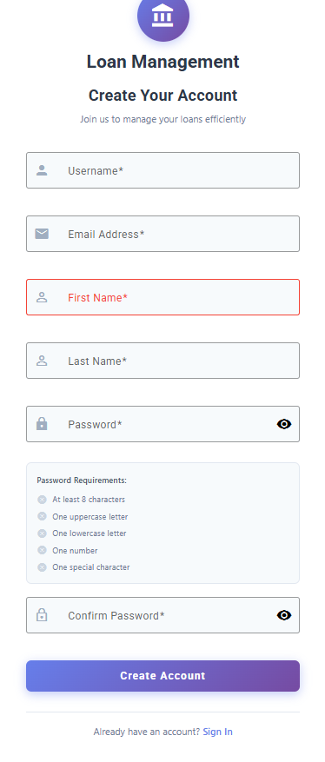

**After successful sign up it will automatically redirect to sign in**

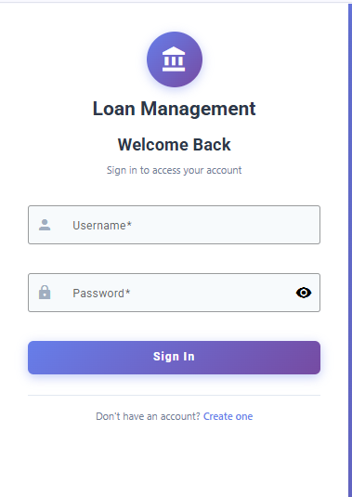

**After successful sign in page will be redirected to complete profile automatically**

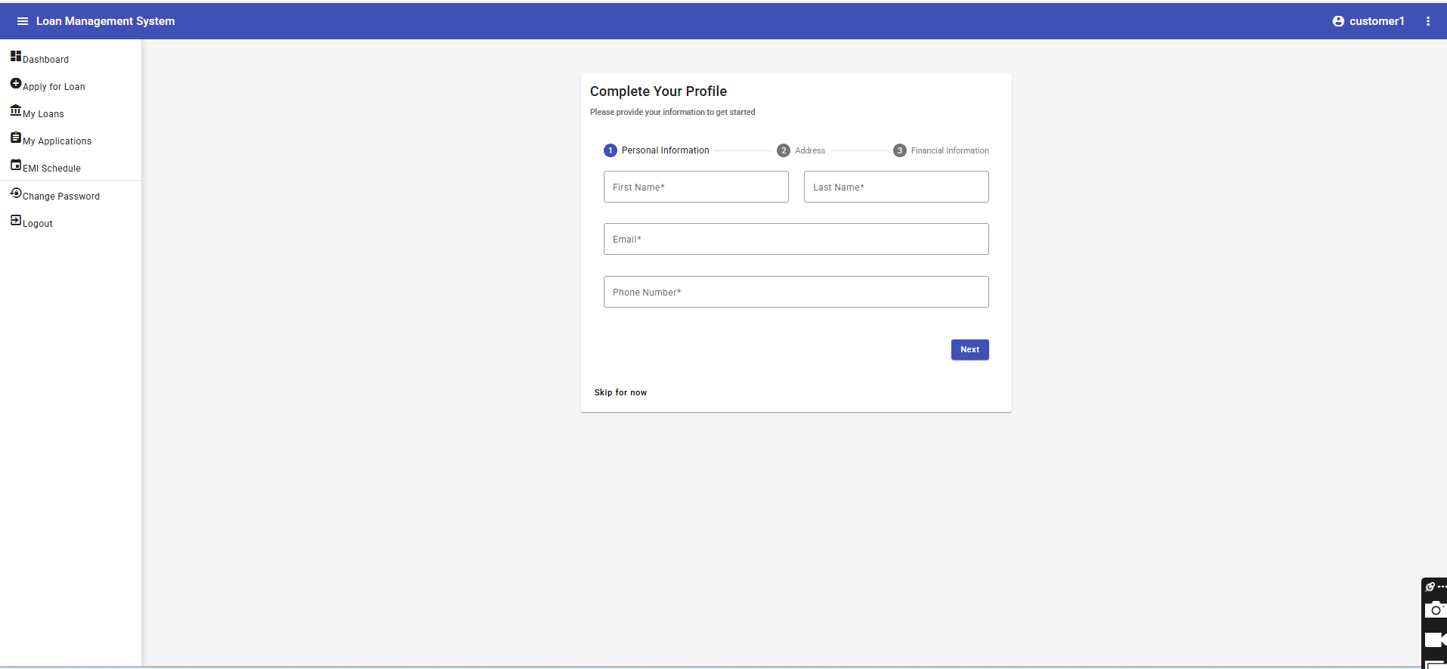

**If we click skip for now it will show like :**

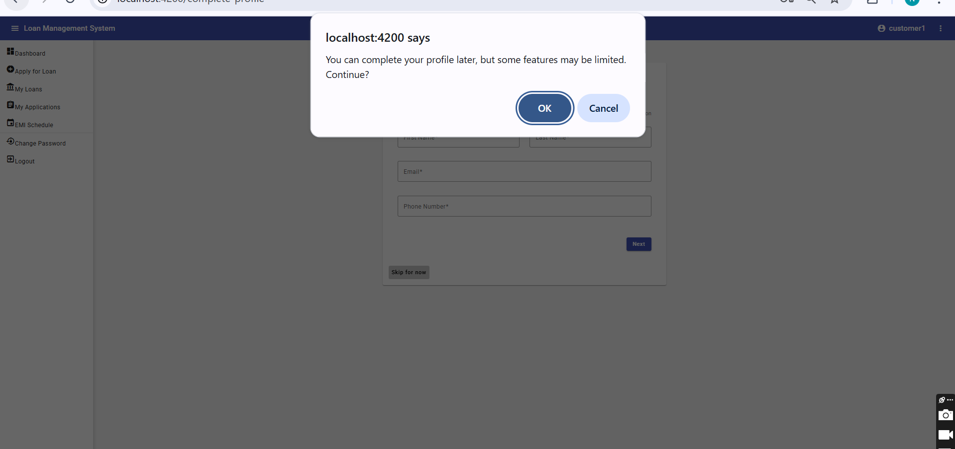

**Because without profiles completion one cant apply for loan**

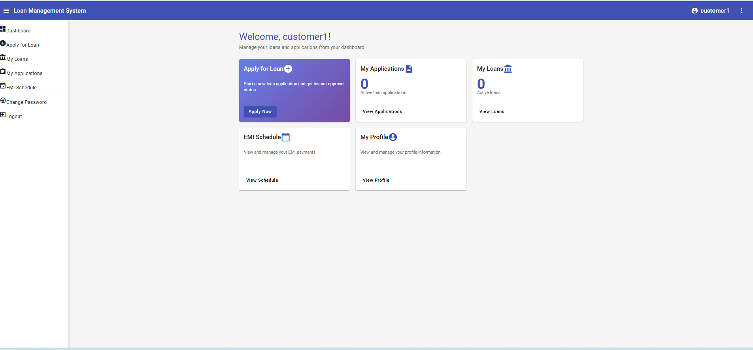

**This is dashboard now let us click on view profile and edit info:**

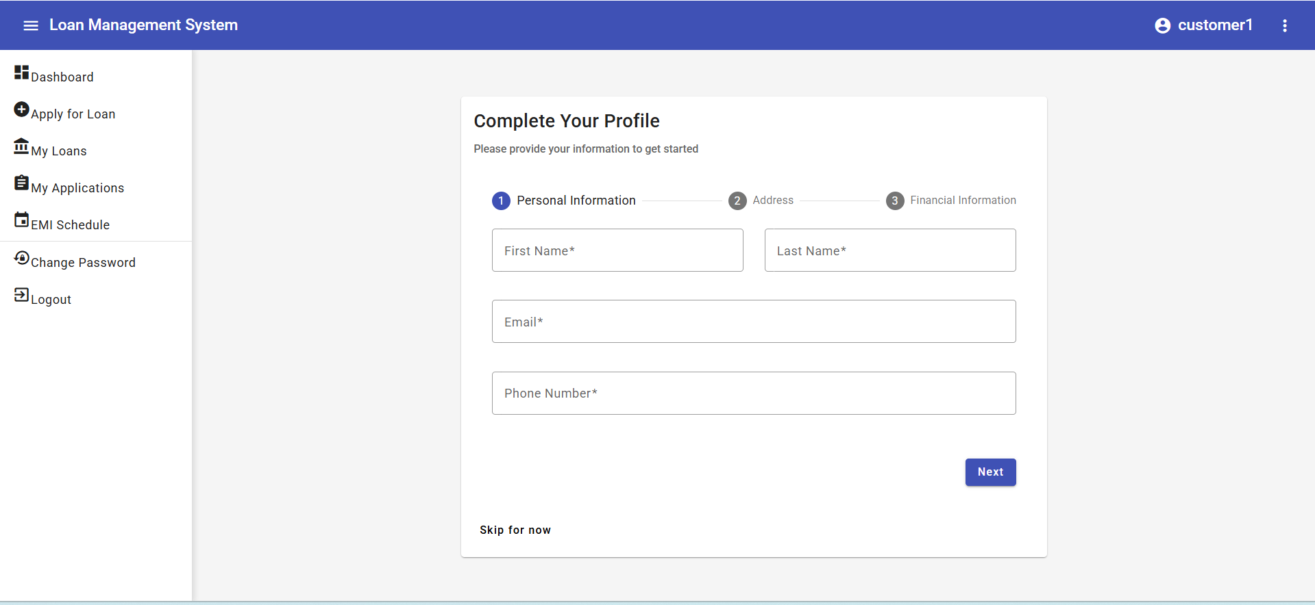

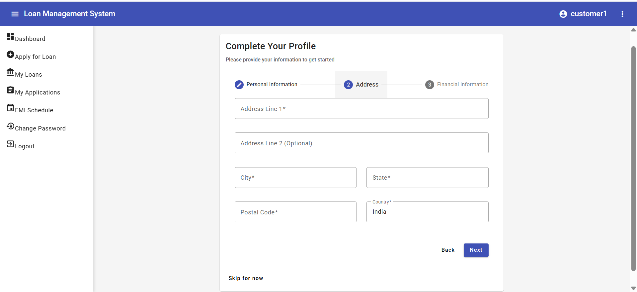

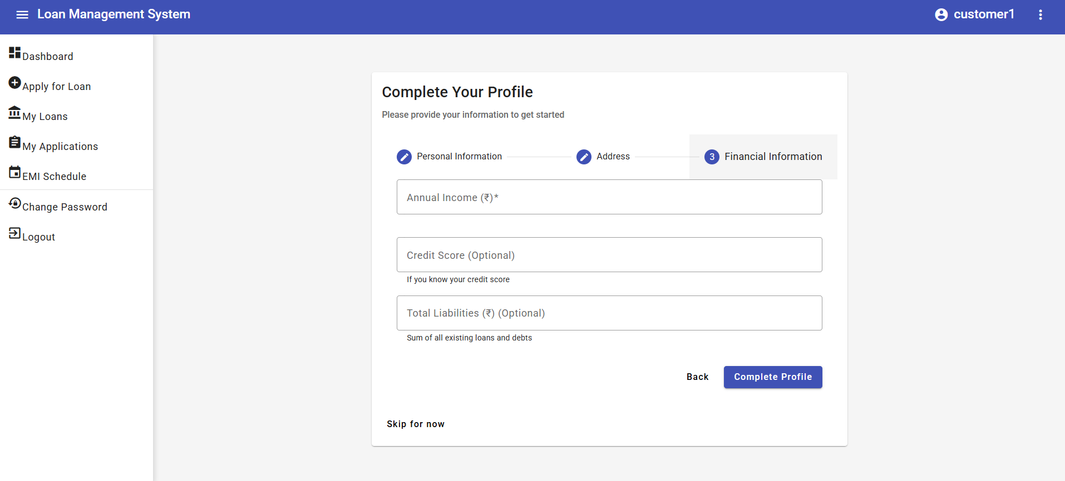

**This is after completing profile** 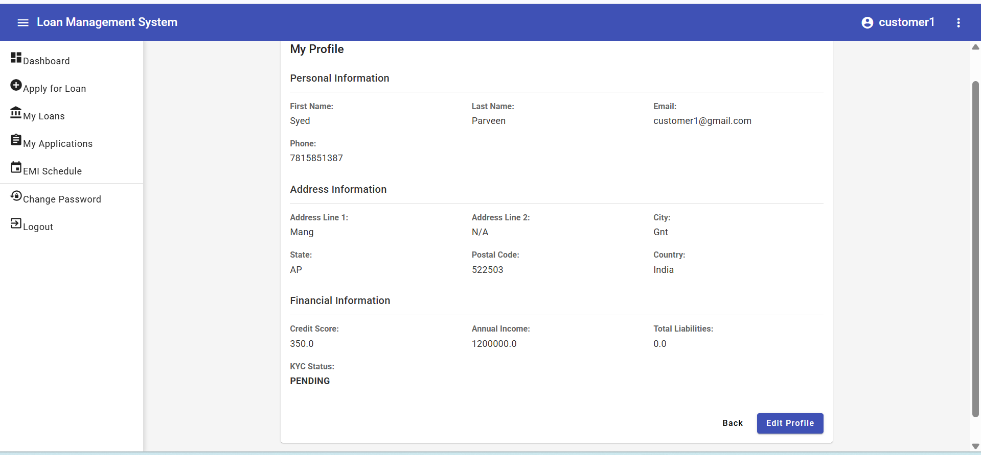

**Let us apply for loan** 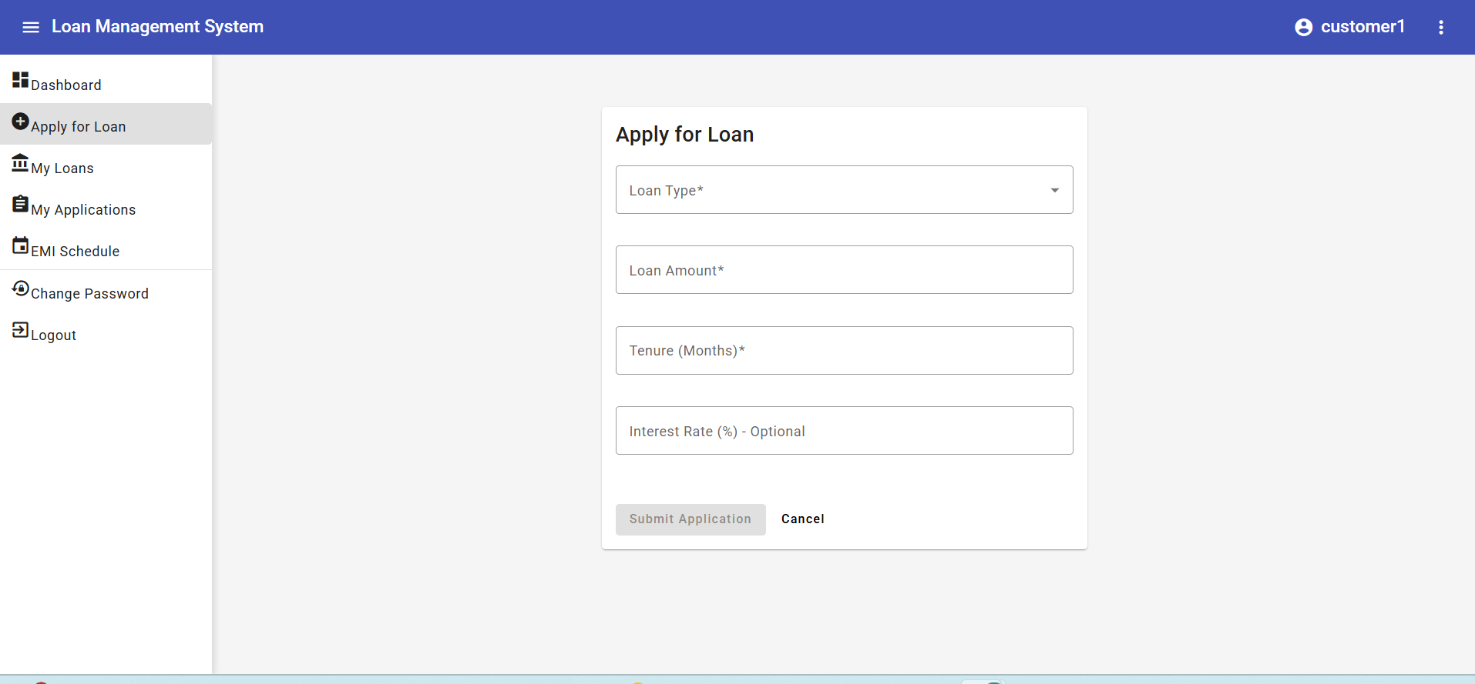

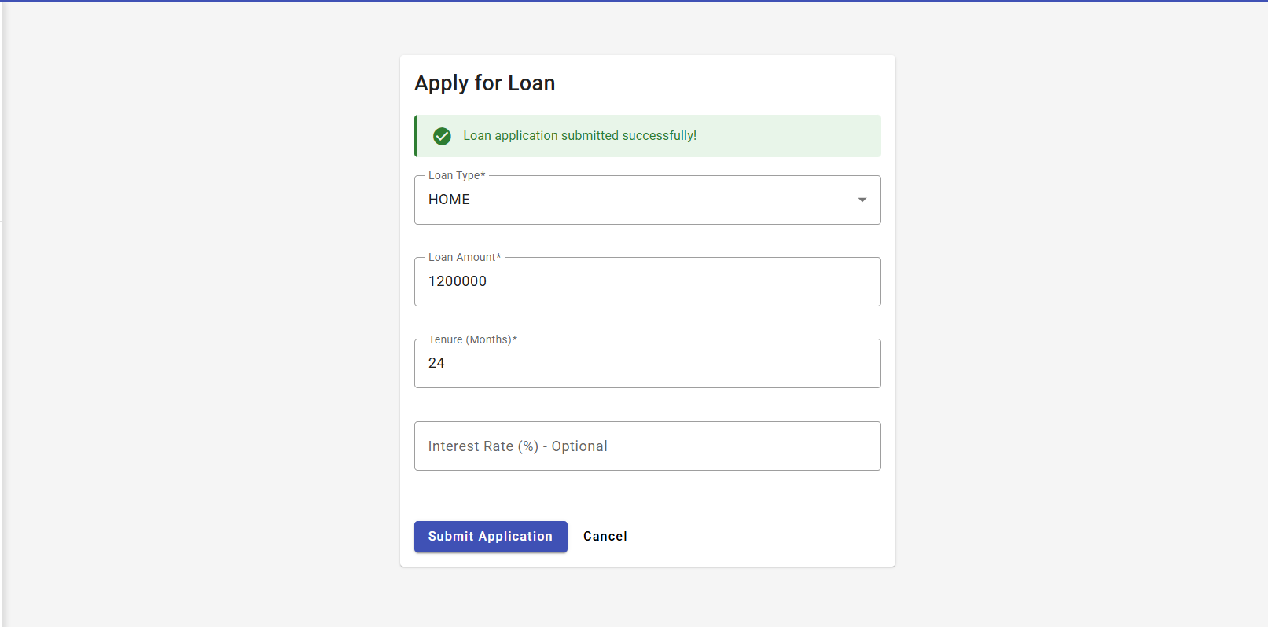

**When u click my applications** 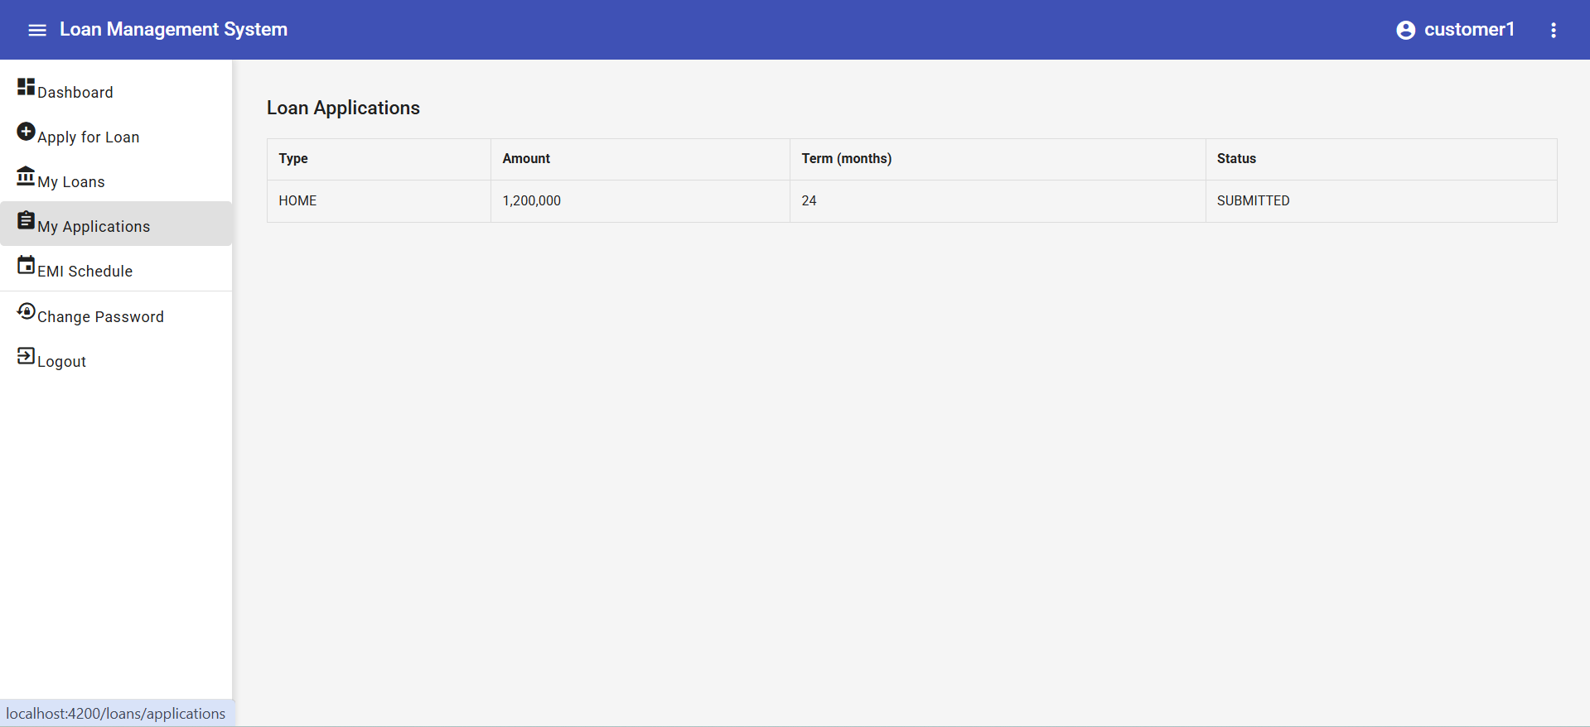

**This will go to my loans only after admin/loan officer approved for now my loans will be empty**

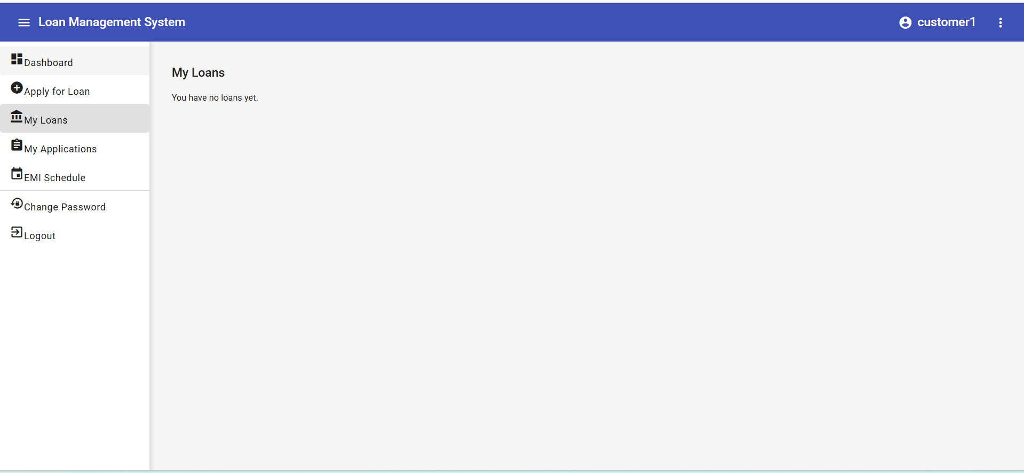

**Admin accepted the loan application so:**

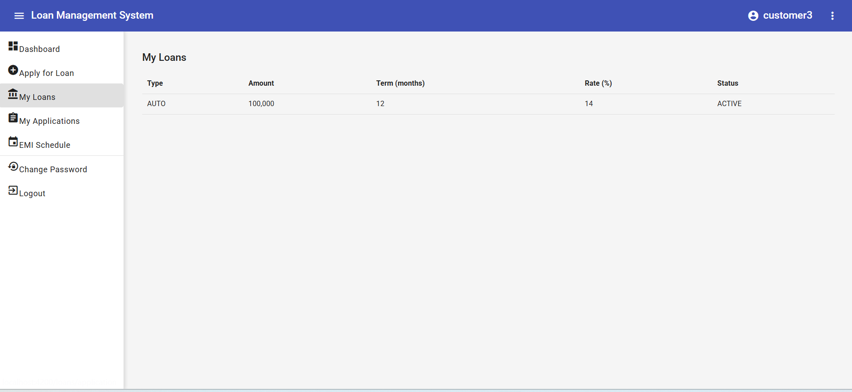

**EMI SCHEDULE will be generated for active loans:**

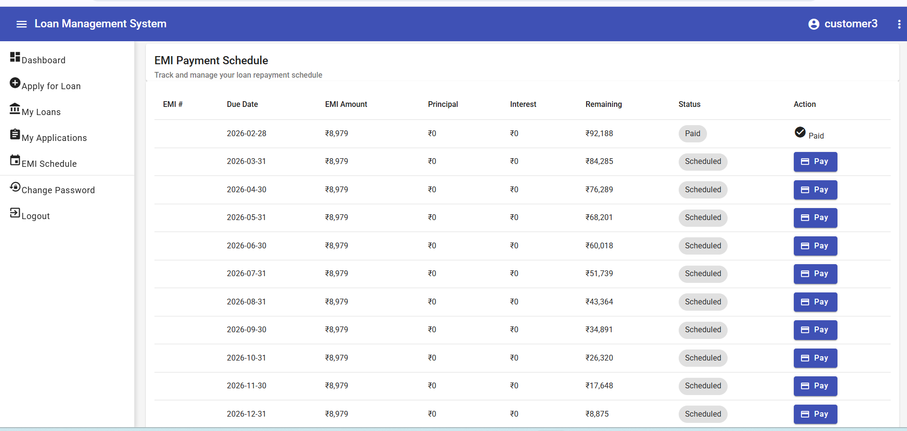

**When we click pay option:**

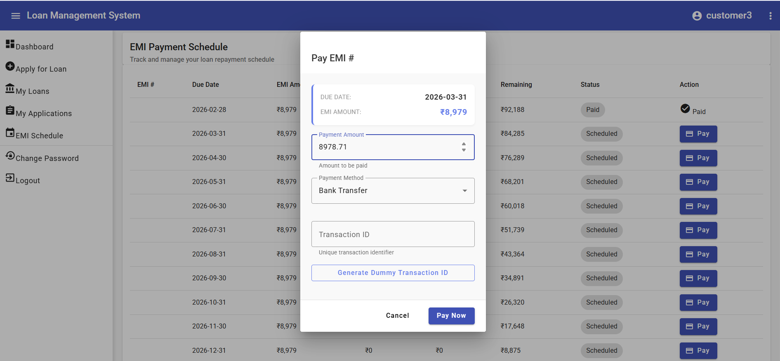

**Payment options are there:**

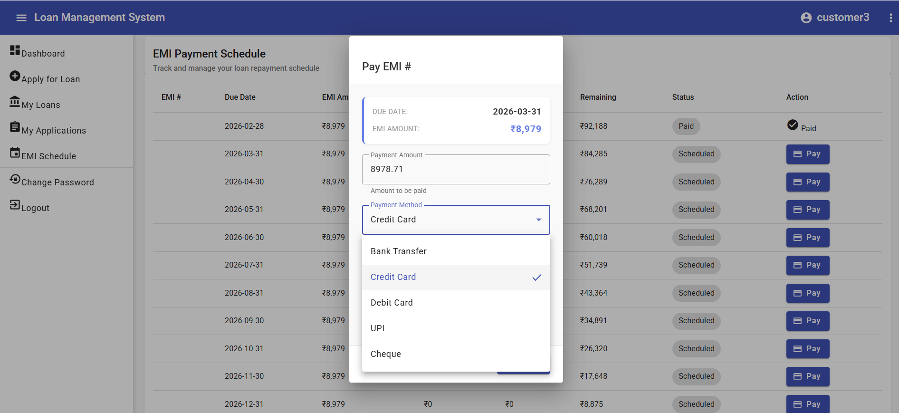

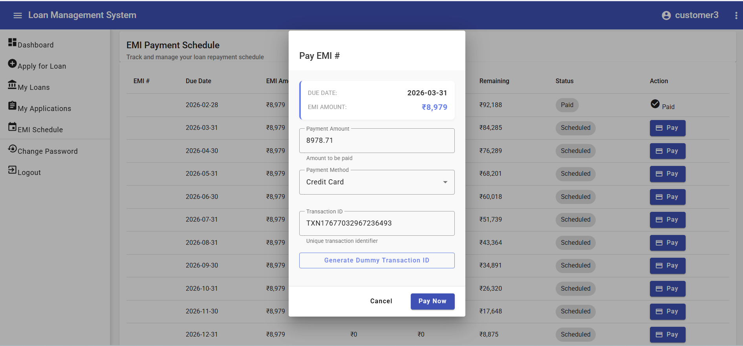

**We can create generate dummy transaction id and click pay button and payment is successfull**

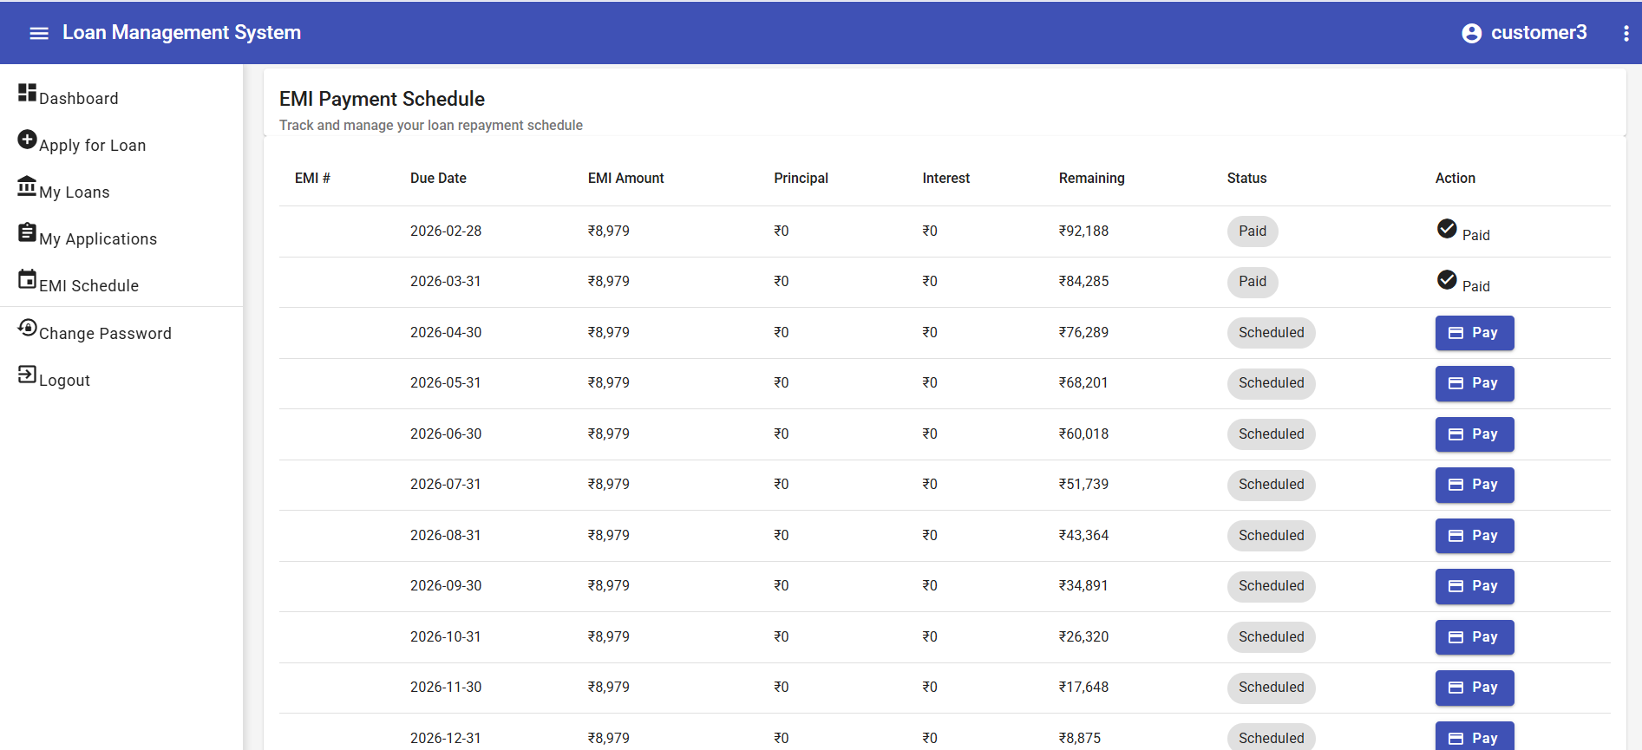

**Change password feature:**

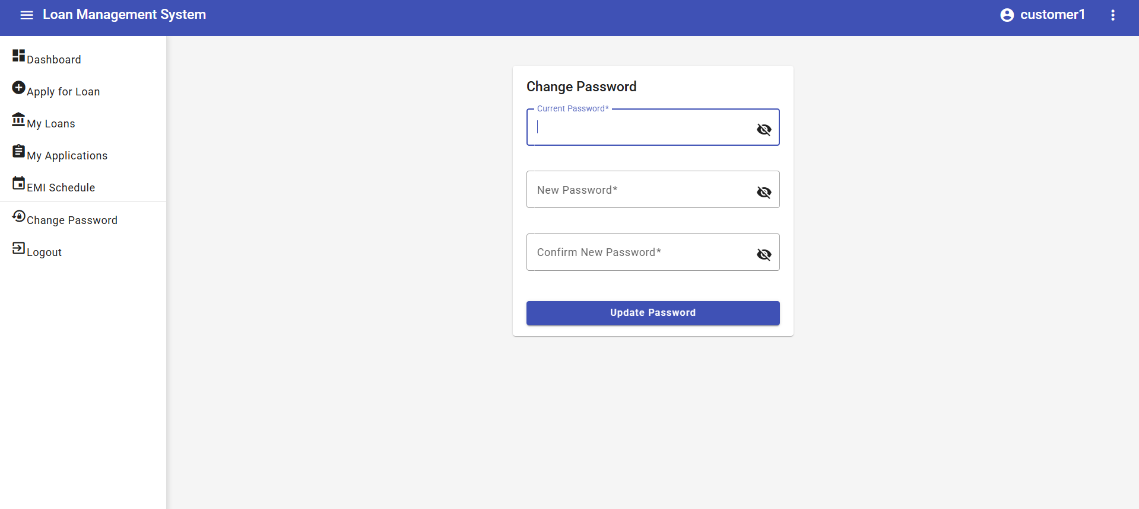

**Some cases of change password:**

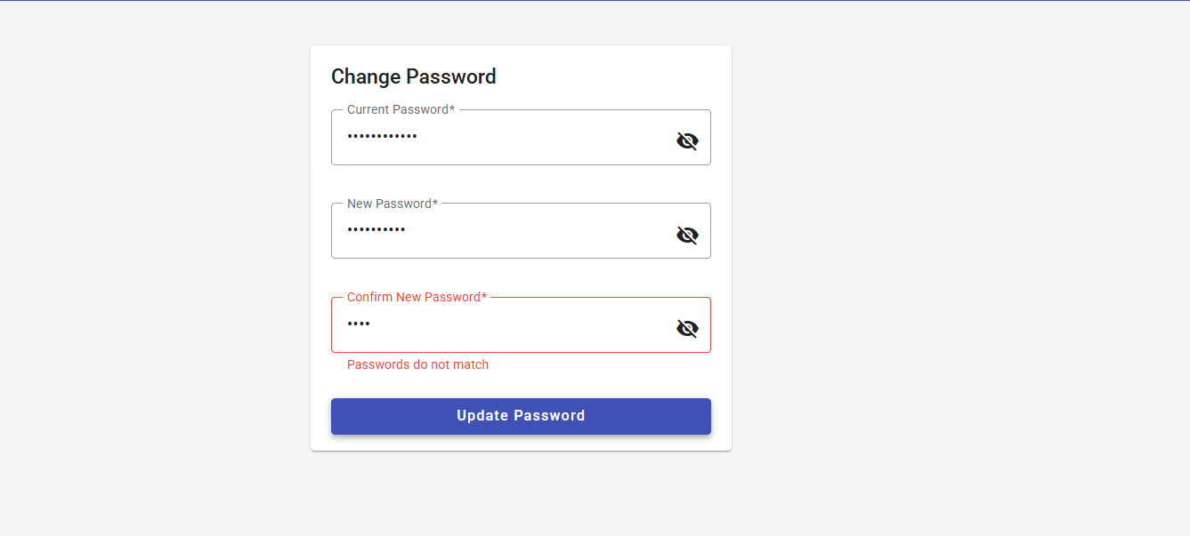

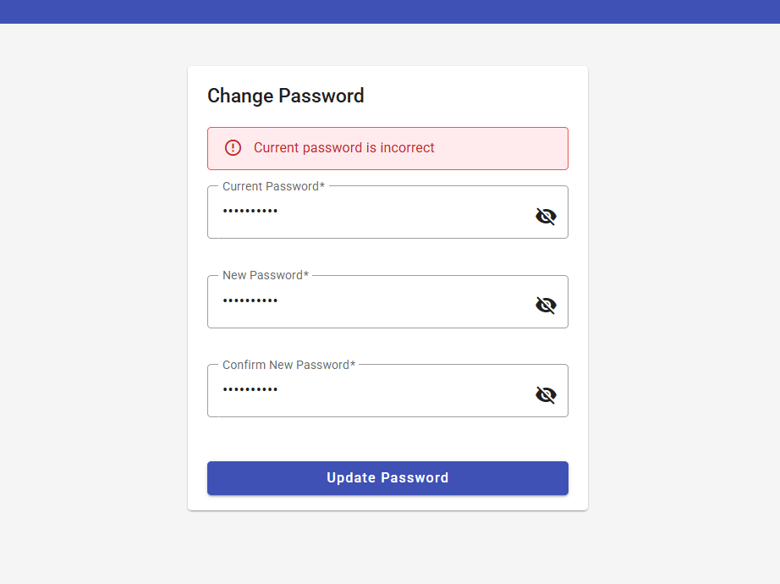

**After successfully changing password we need to relogin (customer1,Sabiha@123)**

**Let us explore admin side:**

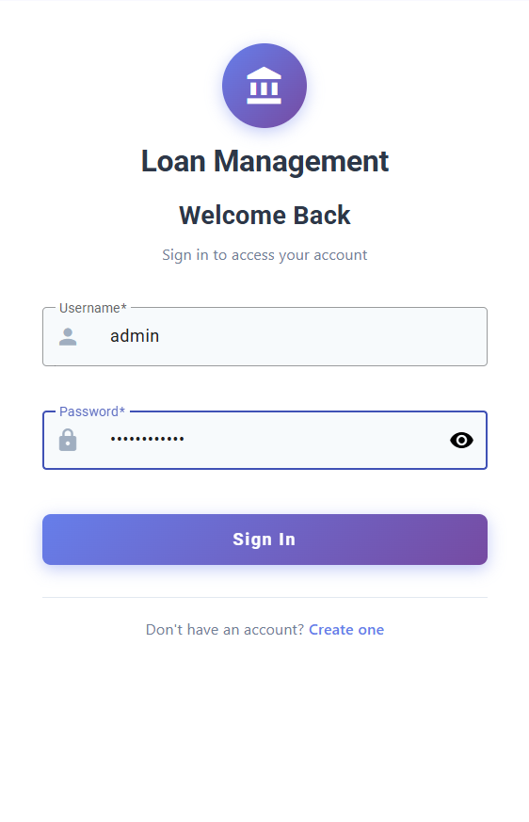

**This is the admin dashboard:**

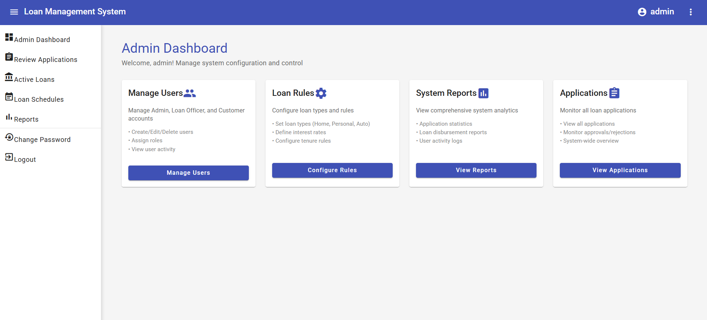

**When I click review applications as admin:**

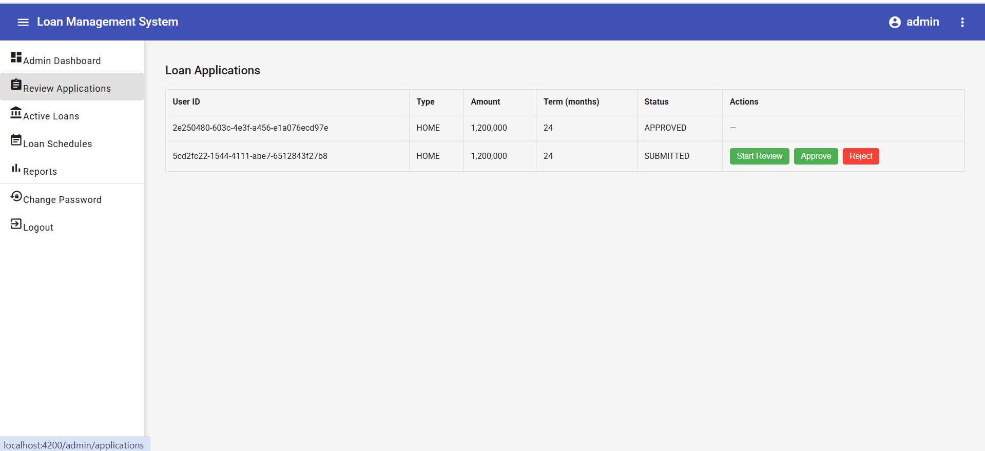

**When I click start review:**

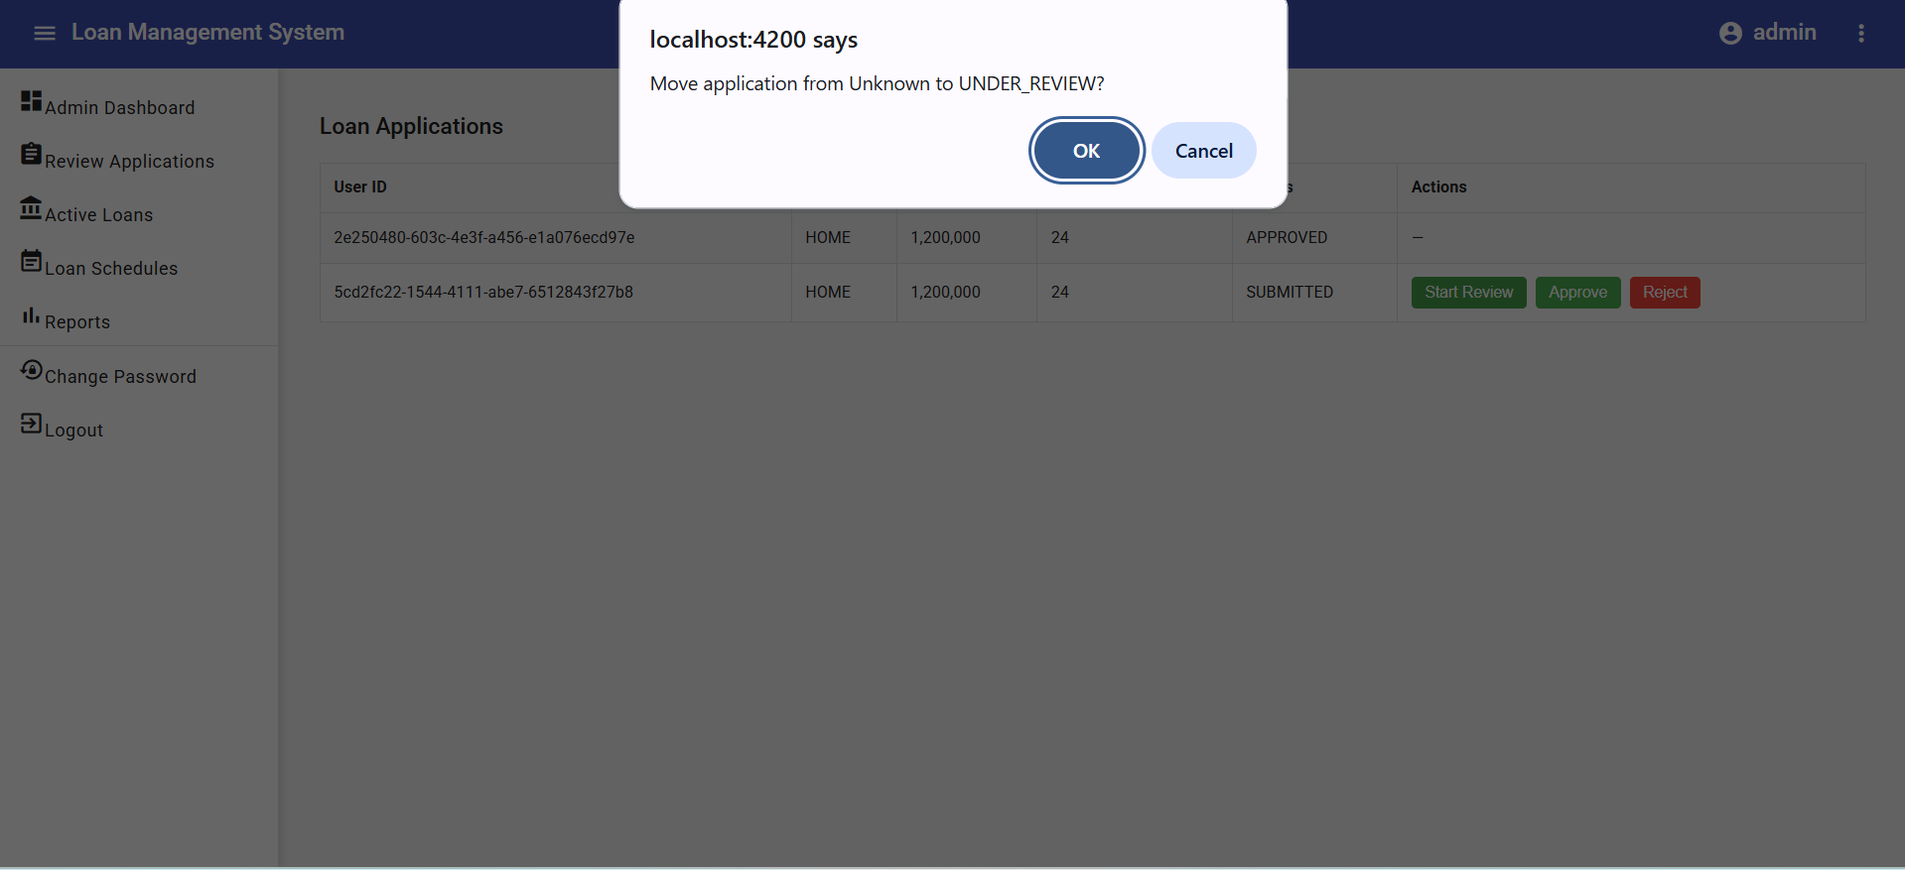

**After clicking ok the status will be submitted to underreview**

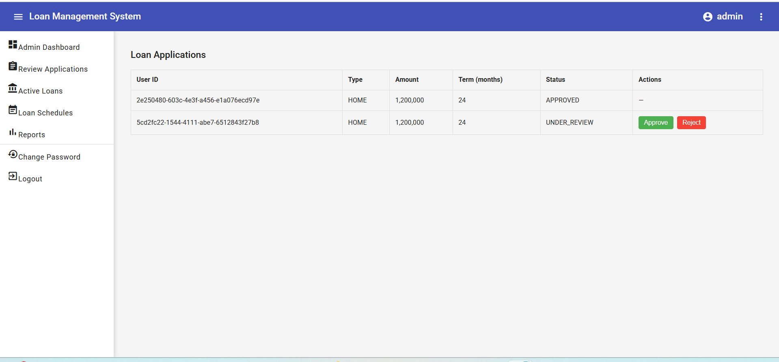

**So admin will decide to approve/reject:**

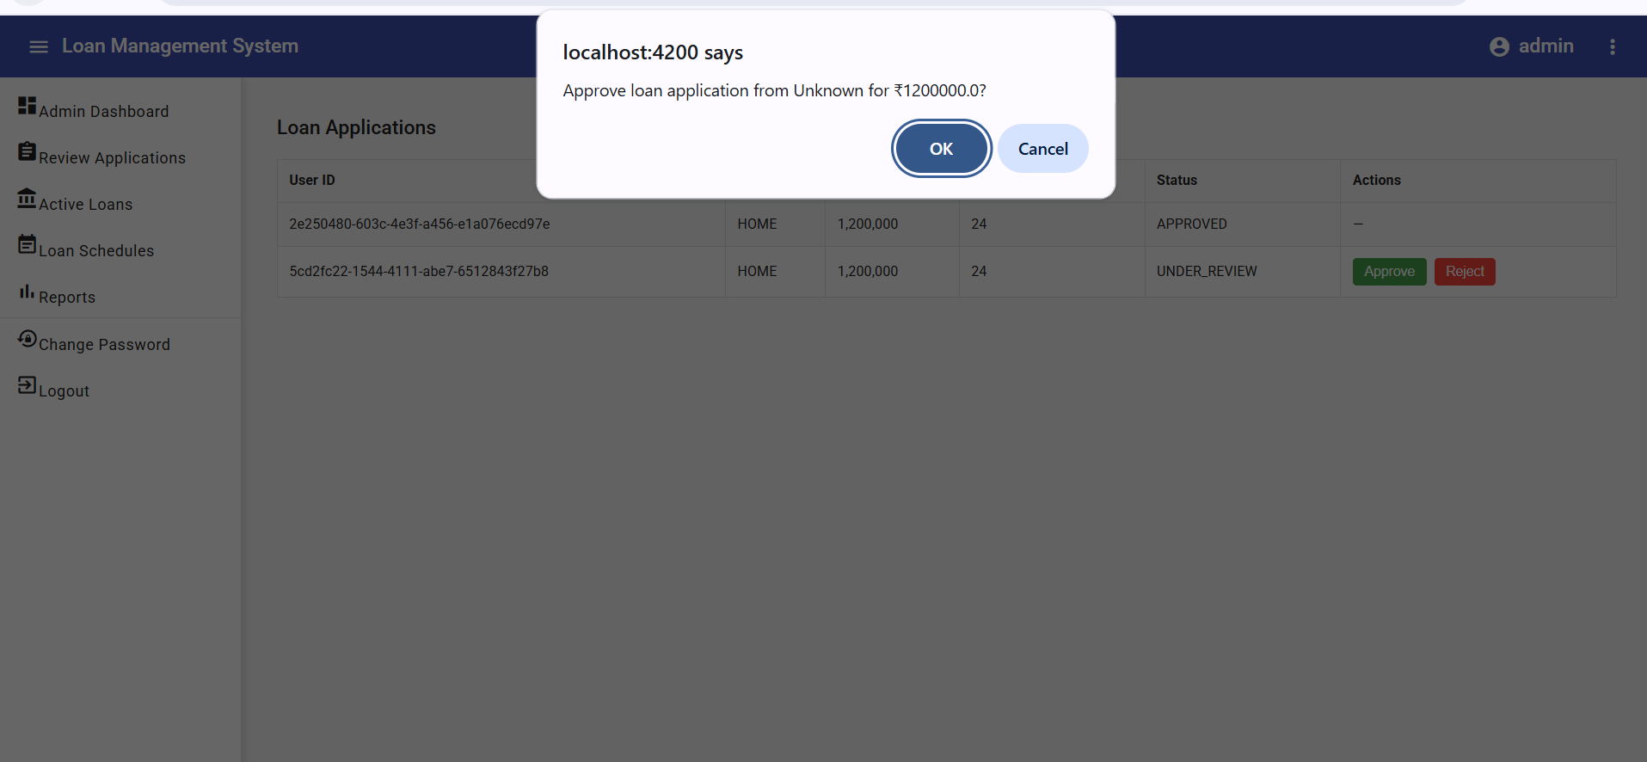

**We click reject reason should be given :**

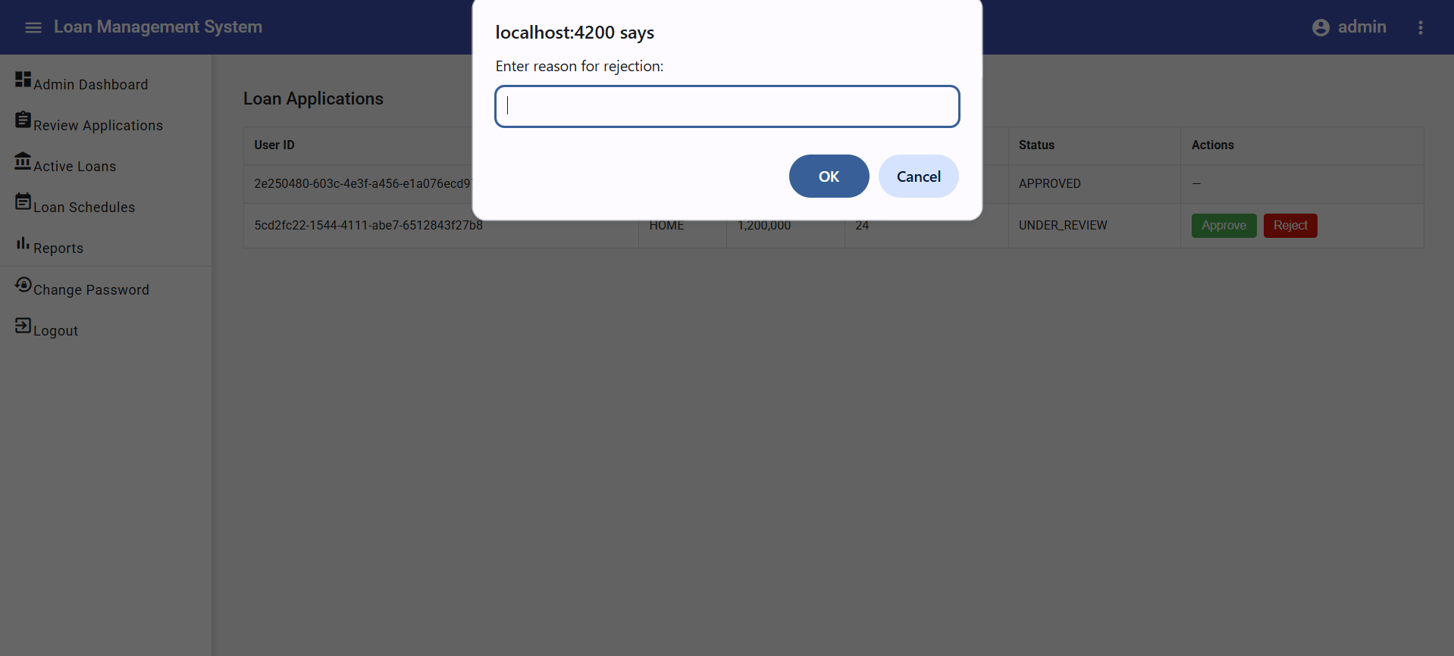

**When loan got approved:**

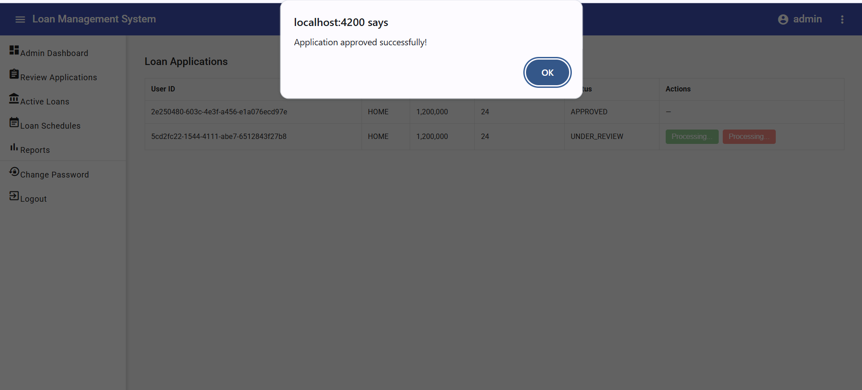

**Now manage users at admin side:**

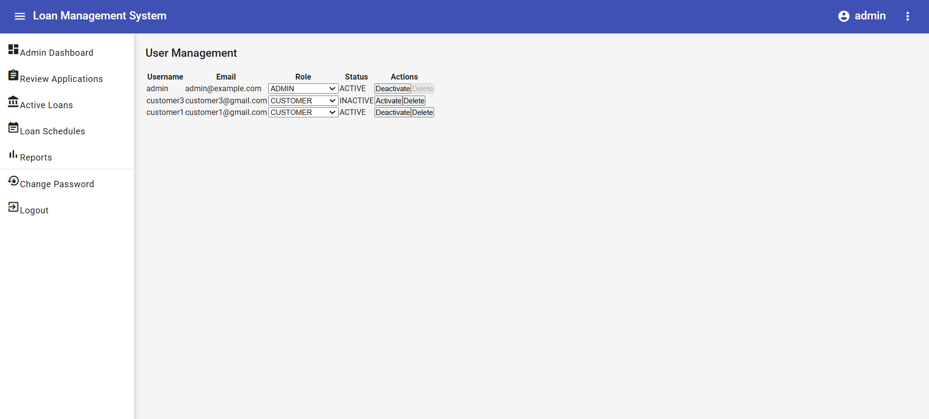

**I have deactivated customer3 as admin**

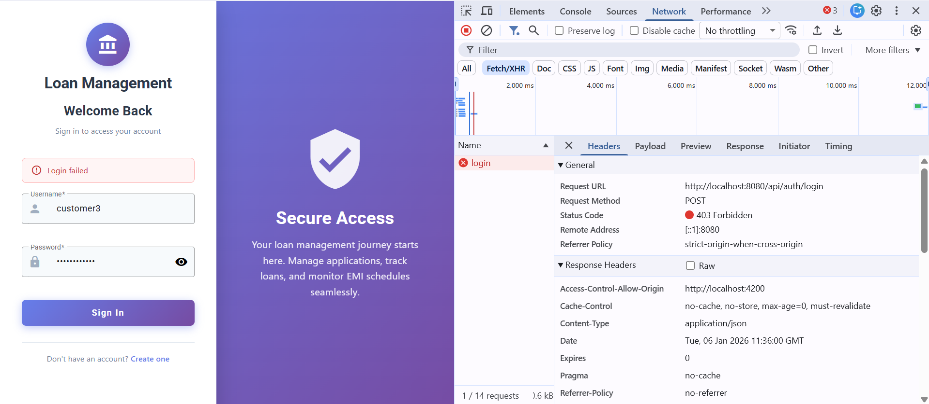

**So customer3 cant login**

**Now admin can change loan rules:**

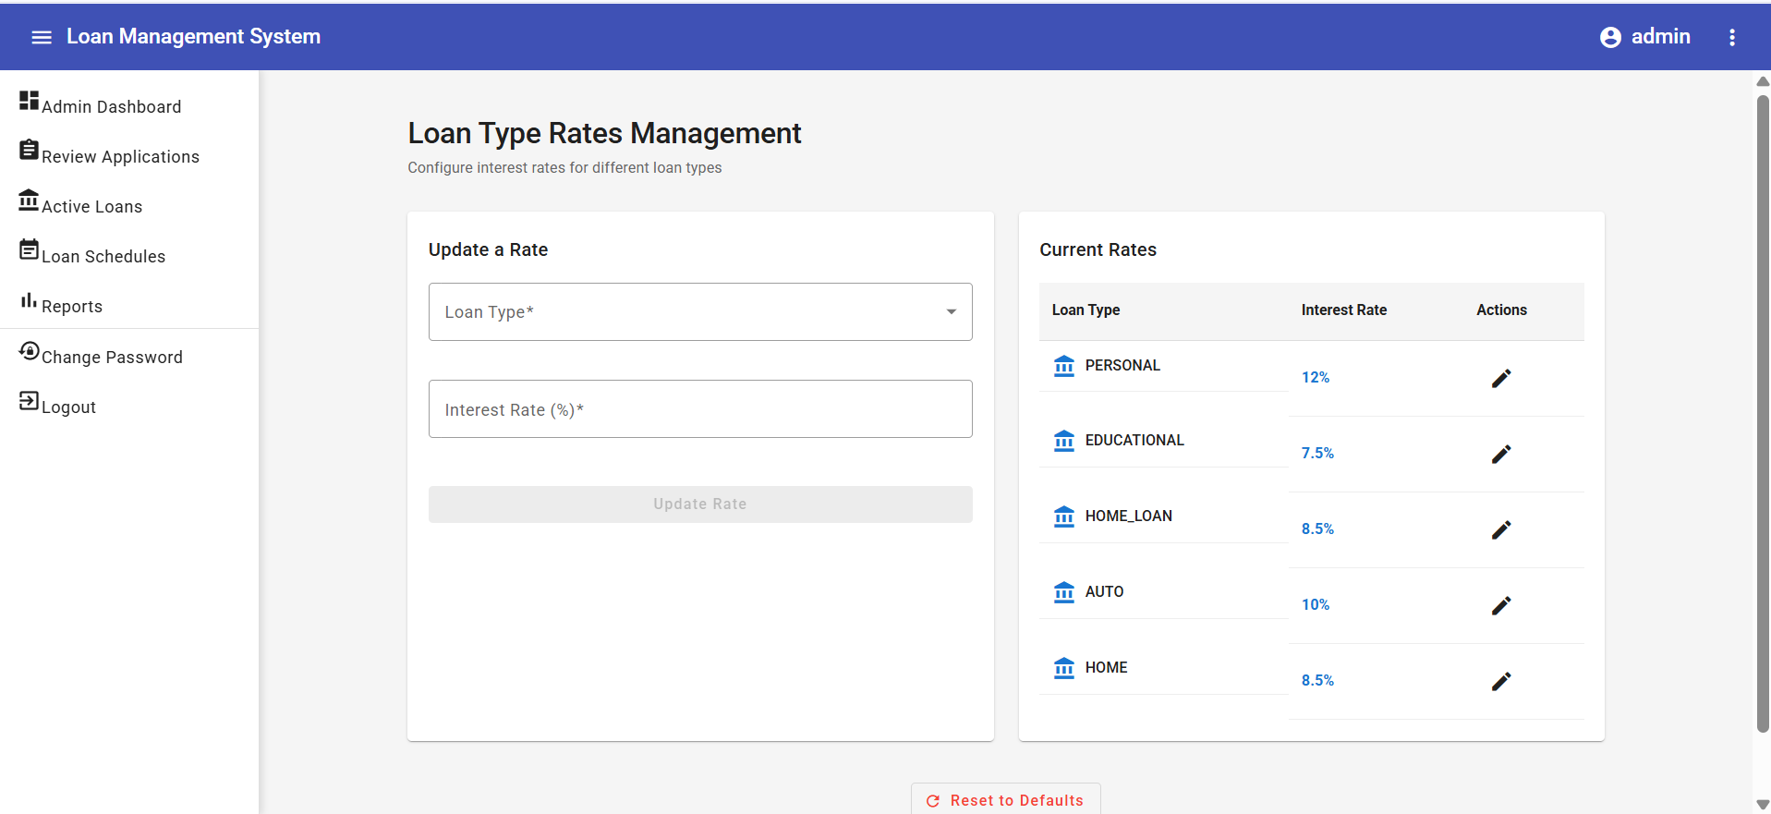

**I have selected personal:**

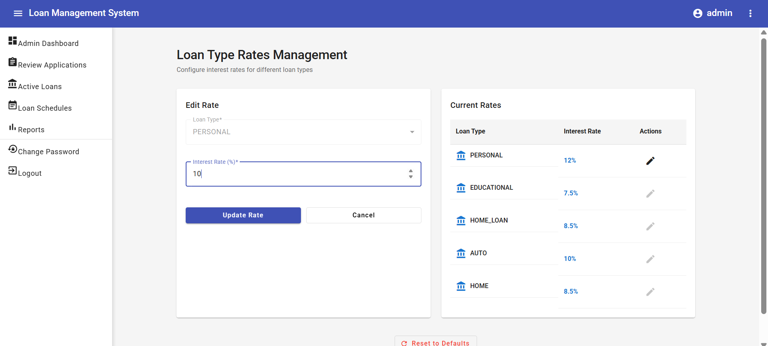

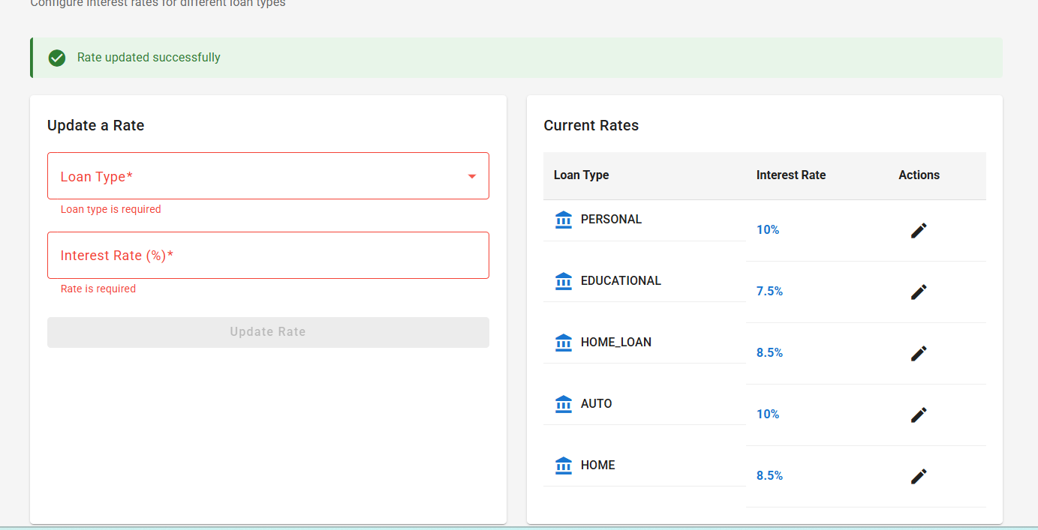

**Successfully changed**

**Reports:**

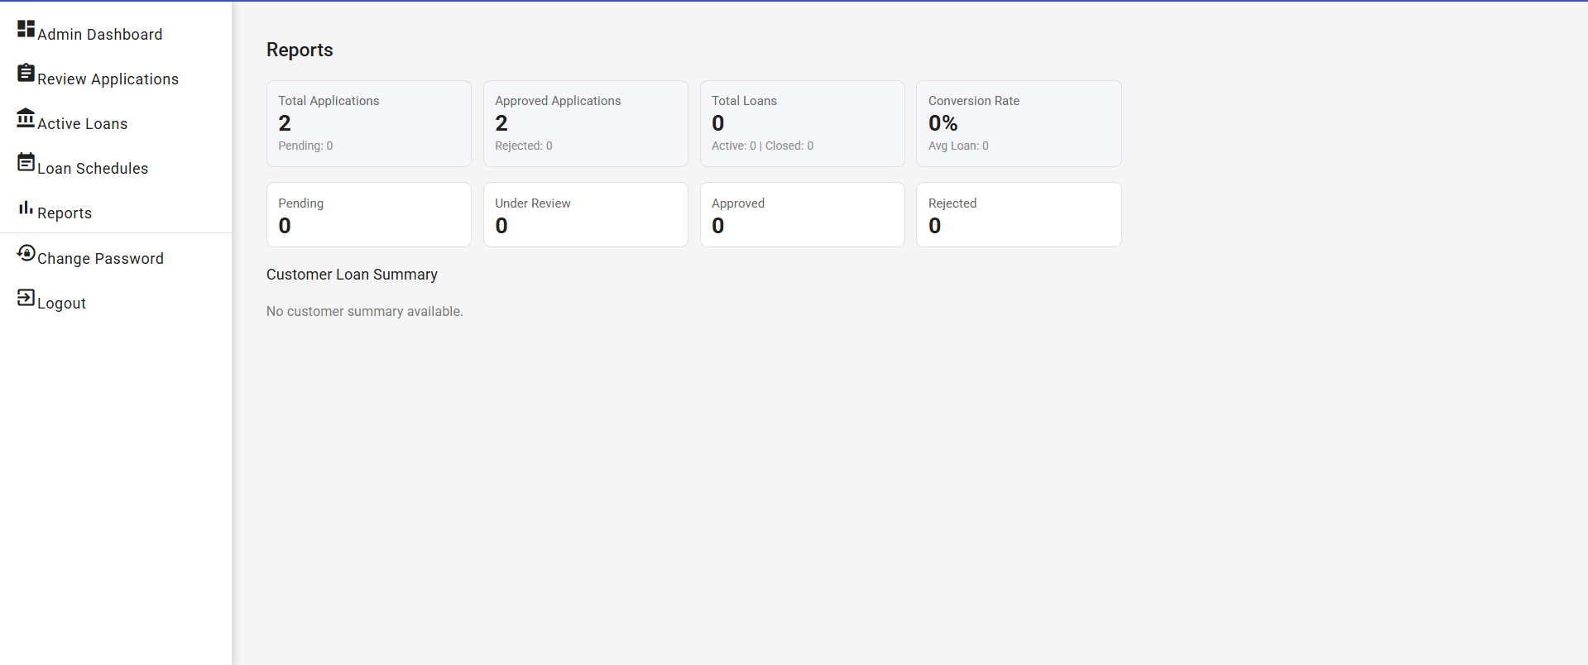

**Admin can see schedules and payments** 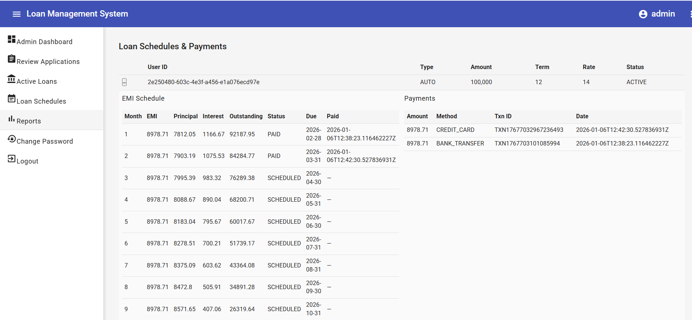

**Reports section:**

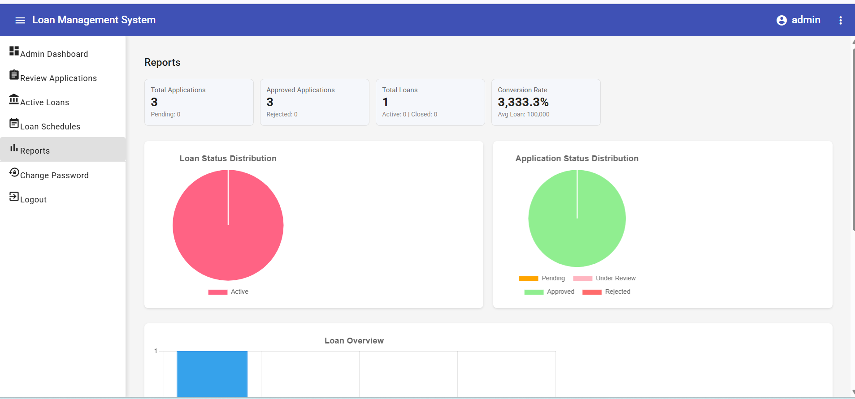

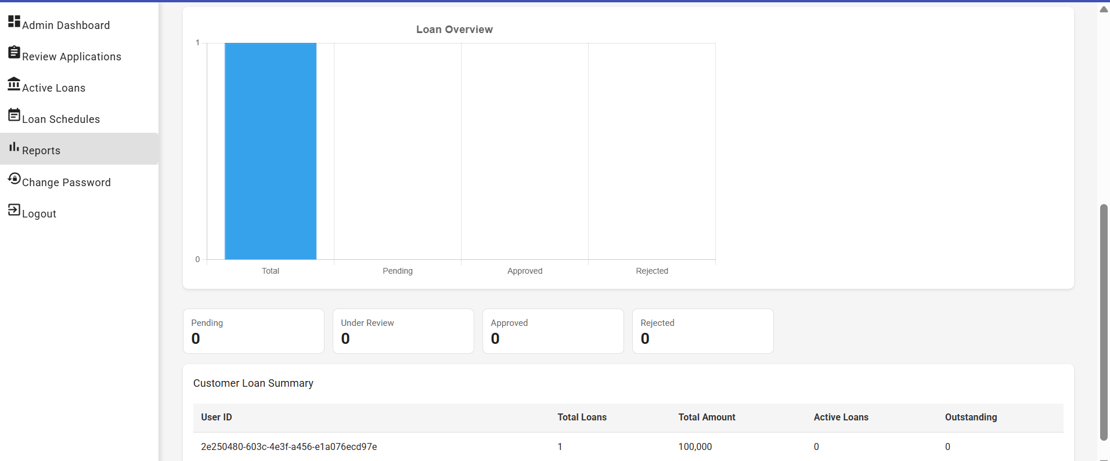

**Let us explore loan_officer dashboard:**

**Sign in as loan-officer:**

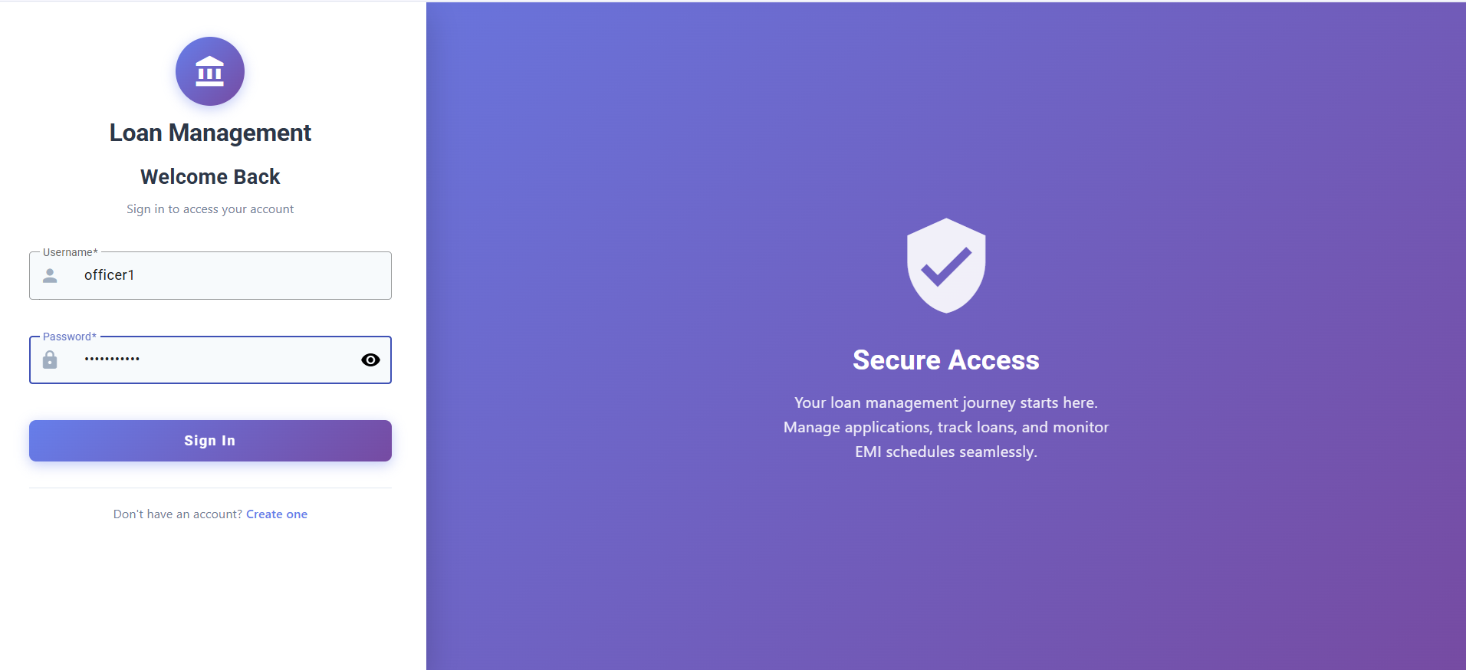

**This is officer dashboard**

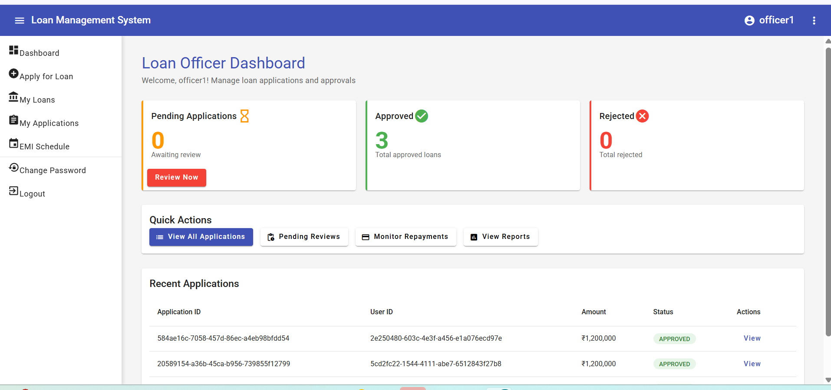

**Everything is same for loan officer and admin …. Officer cant manage users,loan rules Where as admin cant apply for loan**